top-2colsgreen-community

mathcentre community project

encouraging academics to share maths support resources

All mccp resources are released under a Creative Commons licence

Getting started with effective entry of equations in Word

© Emma Cliffe, University of Bath

Reviewer: Peter Rowlett, Nottingham Trent University

by-nc-sa

[www.mathcentre.ac.uk](http://www.mathcentre.ac.uk)

Contents

Purpose of this resource 3

Inserting an equation 3

Important information! 4

Basic structures and symbols 4

Superscripts and subscripts 4

Fractions 4

Linear and professional 5

Roots 5

Accents 5

Examples: Building up equations 5

A wide range of symbols 6

Creating your own shortcuts 6

Functions 6

Examples 7

Creating your own functions 7

Other alphabets 7

Greek 7

Mathematical fonts 7

Stretchy brackets 7

Example: Standard differentiation notation 8

Partial derivatives 8

More complex structures 8

Multi-sized symbols 8

Vectors and matrices 9

Examples 9

Multi-line equations 9

Basic example 9

Over, under, above, below, left and right 10

Examples 10

Numbered equations and references 10

Creating a numbered equation structure 10

Referring to an equation 13

Appendix: General shortcuts 15

Appendix: Alphabets 15

Greek 15

Script 16

Fraktur 16

Double-struck 16

Appendix: Accents 16

Appendix: Stretchy accent-like symbols 17

Appendix: Common symbols with shortcuts 17

Appendix: Multi-sized symbols 18

Brackets 19

# Purpose of this resource

The purpose of this is to provide a starting point to the efficient creation of equations in Microsoft Word. You may be required to produce printed mathematical documents, you may prefer to do so if you find it difficult to handwrite quickly and tidily or you may wish to create electronic notes for your own use. Many people find creating equations slow because they use the mouse. To create equations efficiently you must be able to type them instead. This resource provides guidance as you learn to do this. It is recommended that you try out examples as you go.

# Inserting an equation

The shortcut to insert an equation is

**alt+=**

Hold down the alt key while pressing the = key.

* If you press this within the text it will create an **inline** equation, which will look like:

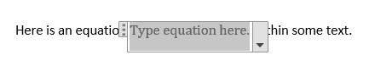

* If you press this on an empty line it will insert a **display** equation, which will look like:

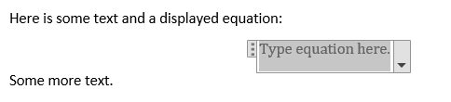

* To change between inline and display equation place your cursor in the equation and press alt-downarrow. Use the arrow keys to choose **change to inline** or **change to display** by pressing h.
* Notice that when you insert an equation, click on the equation box or edit an equation the **ribbon** changes to the **Equation tools**, **Design** ribbon:

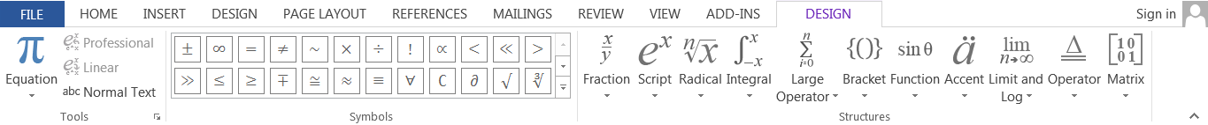

But, you can input an equation using only the keyboard! You might also want to learn some general Word keyboard shortcuts. See Appendix: General shortcuts for a short list.

# Important information!

**In all that follows a ■ means that you need to type a space!**

You should type **precisely** what is written including the spaces! This will not create spaces in your equation – **space is used to trigger** Word to interpret what you have typed so far as mathematical symbols and structures.

# Basic structures and symbols

Once you have inserted the equation you can type any lower or upper case letter, number and the symbols:

+ - / = () [] {} < > % !

Notice however that you are missing a multiplication symbol! You might use a times symbol or a dot for multiplication, depending on what you are writing and your preferences.

|  |  |
| --- | --- |
| $$2×3$$ | 2\times■3 |
| $$2 ⋅3$$ | 2\cdot■3 |

## Superscripts and subscripts

To input a superscript we use ^ as superscripts are **above!** Notice that some sets of round brackets seem to disappear. This is because they are part of the structure of the superscript or subscript. Others remain because they are not part of a structure. If you **also** wanted brackets around the structure you have to use **two** pairs.

|  |  |
| --- | --- |
| $$a^{b+c}$$ | a^(b+c)■ |
| $${\left(a+b\right)}^{\left(c+d\right)}$$ | (a+b)^((c+d))■ |

To input a subscript we use _ as subscripts are **down!**

|  |  |
| --- | --- |
| $$a_{2}$$ | a_2■ |
| $${\left(a+b\right)}_{\left(i+j\right)}$$ | (a+b)_((i+j))■ |

## Fractions

Fractions can be written in two different formats. As fractions become more complicated you have to use brackets to ensure you type the fraction you intend – they are part of the structure. Remember if you want brackets to appear in your fraction as well you have to use **two** sets – one is defining the fraction and one is appearing in the fraction.

|  |  |  |  |
| --- | --- | --- | --- |
| $$\frac{1}{2}$$ | 1/2■ | $$1/2$$ | 1\/2**■** |
| $$\frac{1}{a}+b$$ | 1/a+b | $$\frac{1}{a+b}$$ | 1/(a+b)■ |
| $$\frac{a+b}{c+d}$$ | (a+b)/(c+d)■ | $$\frac{\left(a+b\right)}{\left(c+d\right)}$$ | ((a+b))/((c+d))■ |

### Linear and professional

Place your cursor in the final equation and press alt+downarrow to open the equation menu. Select Linear by pressing l. Notice how the equation now shows something similar to what was typed – though, not always the same. Switch back to professional by opening the menu and selecting p instead. You can use this in other documents to see how an author might have written the equation.

## Roots

A square root symbol is produced with \sqrt. If you want roots other than the square root you still use the same code sqrt and & to separate the inputs. We will see that & is often used to separate information in mathematical structures.

|  |  |
| --- | --- |
| $$\sqrt{2}$$ | \sqrt(2)■ |
| $$\sqrt[n]{2}$$ | \sqrt(n&2)■ |

## Accents

Sometimes we use letters with an accent in mathematics. To type this we type the letter followed by the name of the accent. A full table of available accents is given in the Appendix: Accents.

|  |  |
| --- | --- |
| $$\overline{x}$$ | (x)\bar■■ |

## Examples: Building up equations

|  |  |
| --- | --- |
| $$\overline{x}=\frac{x_{1}+x_{2}+x_{3}+x_{4}+x_{5}}{5}$$ | (x)\bar■■=(x_1+x_2+x_3+x_4+x_5)/5■ |
| $$x=\frac{-b±\sqrt{b^{2}-4ac}}{2a}$$ | x=(-b\pm■\sqrt(b^2■-4ac)■)/(2a)■ |

## A wide range of symbols

To input a symbol you generally type \ followed by the name given to the symbol. Some names will be more obvious than others. A list of the commonly defined symbols which have shortcut names is in Appendix: Common symbols with shortcuts.

|  |  |
| --- | --- |
| $$x≤y$$ | x\leq■y |

### Creating your own shortcuts

Word can create more symbols than there are names defined. If there is a symbol or equation that you wish to use often then you can create your own name. To do this create the equation you wish to give a name by typing alt-= and then locating the symbols using the mouse in the equation design tab e.g.

|  |
| --- |
| $$≰$$ |

Select the symbol or symbols and copy using ctrl-c. With your mouse cursor still in the equation type the shortcut alt-je,t which will bring up the Equation Options window. Click on Math Autocorrect or use the shortcut alt-m. This will open the Math Autocorrect list. Give the symbol or symbols a name in the ‘Replace’ field – it is best to start this with \ and it needs to be something you will remember and type easily. I will call my symbol \nleq for ‘not less than or equal’. Paste your symbol or symbols into the ‘With’ field and press on add or use the shortcut alt-a. Click on OK twice to return to your document. Now try out your new symbol for instance:

|  |  |
| --- | --- |
| $$≰$$ | \nleq■ |

By the above method you can bring up the current symbol list. Have a look through it to see what is there.

## Functions

The following list are the inbuilt recognised functions. When interpreted they are written as a function name in an upright font rather than as a string of italic letters which may look like variables multiplied together. The interpretation is triggered by space or brackets.

acos, acosh, acot, acoth, acsc, acsch, arccos, arccosh, arccot, arccoth, arccsc, arccsch, arcsec, arcsech, arcsin, arcsinh, arctan, arctanh, arg, asec, asech, asin, asinh, atan, atanh, cos, cosh, cot, coth, csc, csch, def, deg, det, dim, erf, exp, gcd, hom, inf, ker, lg, lim, ln, log, max, min, Pr, sec, sech, sin, sinh, sup, tan, tanh

For functions in which the notation makes sense you can usually create the inverse. When you have finished filling in the argument of the function you need to use the right arrow key to move out of the input area. We’ll use the symbol → to mean this from now on.

### Examples

|  |  |
| --- | --- |
| $$\sin{}$$ | sin■ |
| $$\sin^{-1}{}$$ | sin^(-1)■ |
| $$\sin^{-1}{x}$$ | sin^(-1)■x→ |

### Creating your own functions

You can add to the list of recognised functions. Start to insert an equation using alt-= and with your cursor in the equation type the shortcut alt-je,t which will bring up the Equation Options window as before. Click on Recognized Functions or use the shortcut alt-e. This will open the Recognized Functions list. To add a new function type the name in the input box and click on add. When you have finished click on OK and then OK again to close the Equation Options window.

## Other alphabets

### Greek

To input Greek letters you generally type \ followed by the name of the letter and then a space, the name is case sensitive. A full table of Greek letters is in Appendix: Alphabets. For example:

|  |  |
| --- | --- |
| $$δ$$ | \delta■ |
| $$Δ$$ | \Delta■ |

### Mathematical fonts

In addition to being able to create bold text in the usual way there are three mathematical fonts available: script, fraktur and double-struck. To use these you simply type \ followed by the either script, fraktur or double followed by the letter you want in the font then space to trigger. See Appendix: Alphabets for more examples.

|  |  |
| --- | --- |
| $$R,r$$ | \scriptR,\scriptr■ |
| $$R,r$$ | \frakturR,\frakturr■ |
| $$R,r$$ | \doubleR,\doubler■ |

## Stretchy brackets

As we start to write more complicated mathematical structures the height may increase. When we put brackets around such expressions a final space is used to trigger re-sizing of the brackets to match the height of what is contained within. There are various brackets listed in Appendix: Multi-sized symbols.

|  |  |
| --- | --- |
| $$\left(\frac{a}{b}\right)$$ | (a/b)■ |

## Example: Standard differentiation notation

The fraction structure is also used to input differentiation notation.

|  |  |
| --- | --- |
| $$\frac{df}{dx}$$ | df/dx■ |
| $$\frac{d}{dθ}\left(\sin^{-1}{θ}\right)=\frac{1}{\sqrt{1-θ^{2}}}$$ | d/d\theta■■(sin^(-1)■\theta■→)=1/(\sqrt(1-\theta^2))■ |

### Partial derivatives

To input partial differentiation notation we use the symbol \partial which looks like: $∂$. For example:

|  |  |
| --- | --- |
| $$\frac{∂f}{∂x}$$ | \partial■f/\partial■x■ |
| $$\frac{∂}{∂x}\left(f\left(x,y\right)\right)$$ | \partial/\partial■x■(f(x,y))■ |

# More complex structures

## Multi-sized symbols

Some symbols exist in various sizes and may also have sub- and superscripts. The symbols which work in this way are listed in Appendix: Multi-sized symbols. We will see some examples below.

|  |  |
| --- | --- |
| $$∑x_{i},\sum{x_{i}}$$ | \sum■x_i,\sum■■x_i■→ |
| $$\sum_{k=1}^{n}{k}=\frac{1}{2}n(n+1)$$ | \sum_(k=1)^n■k→=1/2■n(n+1) |
| $$\overline{x}=\frac{\sum_{i=1}^{n}{x_{i}}}{n}$$ | (x)\bar■■=(\sum_(i=1)^n■x_i■→)/n■ |
| $$∫xdx, \int{xdx}$$ | \int■xdx,\int■■xdx→ |
| $$\int_{a}^{b}{f\left(u\right)\frac{du}{dx}}dx=\int_{u\left(a\right)}^{u\left(b\right)}{f\left(u\right)du}$$ | \int_a^b■f(u)■■du/dx■dx→=\int_(u(a))^(u(b))■f(u)du |

## Vectors and matrices

Vectors and matrices are input using ‘matrix’ notation.

|  |  |
| --- | --- |
| **Code** | **Use** |
| \matrix(…) | Container for the matrix |
| & | Separator |
| @ | New row |

### Examples

|  |  |
| --- | --- |
| $$\left(\begin{matrix}1 & 0 & 0 \\ 0 & 1 & 0 \\ 0 & 0 & 1\end{matrix}\right)$$ | (\matrix(1&0&0@0&1&0@0&0&1)■)■ |
| $$\left(\begin{matrix}1 & ⋯ & 0 \\ ⋮ & ⋱ & ⋮ \\ 0 & ⋯ & 1\end{matrix}\right)$$ | (\matrix(1&\cdots&0@\vdots&\ddots&\vdots@0&\cdots&1)■)■ |

## Multi-line equations

Multi-line equations are display equations which continue over multiple lines, often aligned at an equals sign or operator. The standard way to achieve this in Word requires you to use the mouse to set the alignment point and this is time-consuming. A more effective way is to type the entire multi-line equation as an equation array though this requires practise. The method is similar to input of a matrix and allows you to place the separators and newlines as you go.

|  |  |
| --- | --- |
| **Code** | **Use** |
| \eqarray(…) | Container for the equation array |
| & | Separator (alignment point) |
| @ | New line |

### Basic example

|  |  |
| --- | --- |
| $$\begin{aligned}x&=1+2+3 \\ &=6\end{aligned}$$ | \eqarray(x&=1+2+3@&=6)■ |

## Over, under, above, below, left and right

We have seen how to produce subscripts, superscripts and accents. There are also commands for producing stretchy accent-like symbols over or under other expressions. A full list is in Appendix: Stretchy accent-like symbols.

|  |  |
| --- | --- |
| $$\overset{z}{\overbrace{x+y}}$$ | \overbrace(x+y)^z■ |
| $$\underset{z}{\underbrace{x+y}}$$ | \underbrace(x+y)_z■ |

There are also commands for placing groups of symbols above or below a symbol or group of symbols:

|  |  |
| --- | --- |
| $$\underset{→}{x}$$ | \to\above■(x)■ |
| $$\overset{→}{x}$$ | \to\below■(x)■ |

Finally, sometimes we want a bracket to stretch to the height of an expression but in the case where there is no matching bracket. To achieve this we use the commands \left or \right. An example of this is given below.

### Examples

|  |  |
| --- | --- |
| $$e^{x}=\lim_{n→∞}{\left(1+\frac{x}{n}\right)}^{n}$$ | e^x■=lim\below(n\to■\infty)■(1+x/n)^n■ |
| $$f\left(x\right)=\left\{\begin{aligned}-x, &x<0 \\ x, &x≥0\end{aligned}\right.$$ | f(x)={\eqarray(-x,\emsp&x<0@  x,\emsp&x\geq■0)■\right■■ |

Notice that in the above we have adjusted the spacing using \emsp. If you want a smaller space use \ensp instead.

## Numbered equations and references

At the time of writing there is no in-built numbering of equations which:

* matches that usually used in mathematical documents and
* enables the writer to refer to the equation by auto-updated number in the text.

It is possible to create such a numbered equation but it is time-consuming enough that you will want to create an auto-correct which inserts the structure for you. This section contains the steps to do this, you will only have to do this once.

### Creating a numbered equation structure

Create a one-row, three-column table by clicking on the INSERT tab, then the drop-down arrow under Table and highlighting a single row of 3 boxes (or type alt-n,t,i to bring up the table insert dialogue if you prefer).

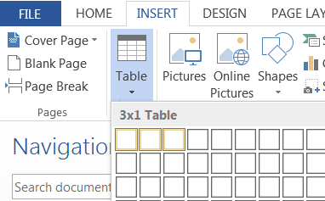

This will insert:

|  |  |  |
| --- | --- | --- |
|  |  |  |

Adjust the left and right most columns to be about 1.5cm.

|  |  |  |
| --- | --- | --- |
|  |  |  |

Place your cursor in the middle column and insert an empty equation using alt+=

|  |  |  |
| --- | --- | --- |
|  | |  |

Place your cursor in the right column and press alt-i then f and the **insert field window** will appear (or select insert field from the INSERT tab, button Explore Quick Parts, option field).

1. For Categories select **Numbering**
2. For Field names select **Seq**
3. In the Field codes text box it will say **SEQ** add a string to describe the sequence e.g. EqNum so it reads **SEQ EqNum.** This is shown below.

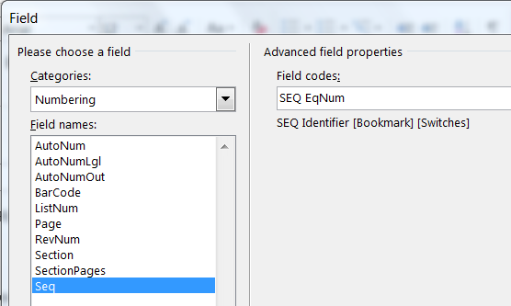

Press okay and this will result in:

|  |  |  |
| --- | --- | --- |
|  | | 1 |

Place brackets around the number:

|  |  |  |
| --- | --- | --- |
|  | | (1) |

And finally, hide the borders of the table by selecting the table, clicking on the TABLE TOOLS DESIGN tab and selecting No Border from the Borders menu as shown (type alt-jt,b,n):

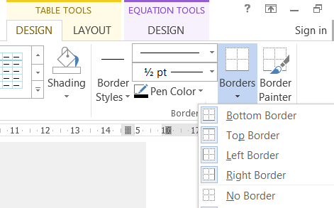

This will result in:

|  |  |  |
| --- | --- | --- |
|  |  | () |

So that you do not need to do this again you should save the structure as an auto-correct. To do this select the whole table and then type alt-i,a.c. The **Create New Building Block Window** will open (or from the INSERT tab, button Explore Quick Parts, option AutoText, option Save Selection to AutoText gallery). Give your structure a name that you will find easy to remember and type and that is not a word you would usually use e.g. EqNum. In future when you type this and press enter your empty numbered equation structure will be inserted:

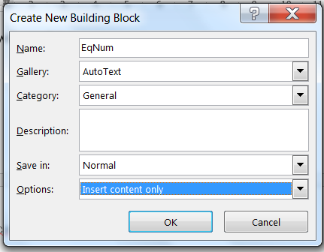

Try this now! On a new line start to type the name that you used and when asked press enter. You should get a new copy of the structure. If you have done this in the same document as you created the first structure the number of the equation should be (2):

|  |  |  |
| --- | --- | --- |
|  |  | () |

You can now add an equation by clicking on where it says type equation here or using the arrow keys to move to the same position, for instance:

|  |  |  |
| --- | --- | --- |
|  |  | () |

The equation numbers will automatically increment.

### Referring to an equation

If you wish to refer to one of the numbered equations in the text then you will need to **bookmark** the equation number. To do this select the bracketed equation number with your mouse or with the arrow keys and press ctrl-shift-F5 (or under the INSERT tab, Links button, option Bookmark) this will open the **Bookmark Window**. Give the equation a name and press Add:

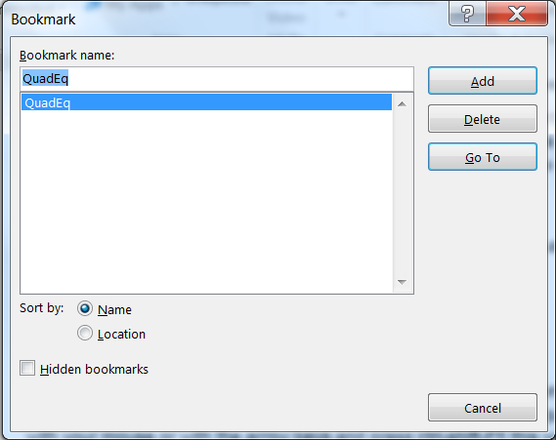

Bookmarks can be editing by selecting and pressing the same keyboard combination. When you want to refer to the equation in the text you need to create a **cross-reference**. To do this use the keyboard shortcut alt-s,r,f (or under the REFERENCES tab, button Cross-reference). This will open the **Cross-reference Window**. Select Reference type **Bookmark** (NOT equation!), select the name of the bookmark you wish to reference and press Insert, then close.

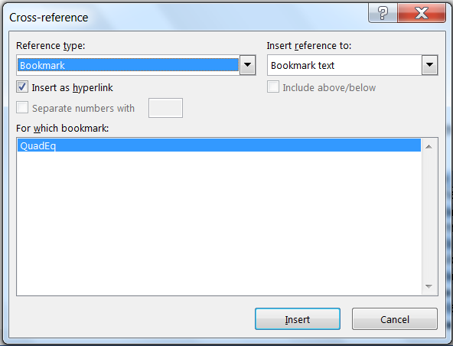

For example, I can reference equation (3).

# Appendix: General shortcuts

This is a list of keyboard shortcuts for efficient editing of a Word document. For example if the shortcut is ctrl+b you need to press the key with ctrl written on it and press the b key at the same time. You can hold down the ctrl (control) key and the shift key while you press the other keys.

|  |  |
| --- | --- |
| To select text letter by letter | Shift+left or right arrow key |
| To select text word by word | Ctrl+shift+left or right arrow key |
| To copy selected text | Ctrl+c |
| To cut selected text | Ctrl+x |
| To paste text | Ctrl+v |
| To undo | Ctrl+z |
| To make selected text bold | Ctrl+b |
| To make selected text italicised | Ctrl+i |
| To make selected text underlined | Ctrl+u |
| To save the document | Ctrl+s |

# Appendix: Alphabets

## Greek

|  |  |  |  |
| --- | --- | --- | --- |
| Lower case | Type | Upper case | Type |
| $$α$$ | \alpha■ | $$Α$$ | \Alpha■ |
| $$β$$ | \beta■ | $$Β$$ | \Beta■ |
| $$γ$$ | \gamma■ | $$Γ$$ | \Gamma■ |
| $$δ$$ | \delta■ | $$Δ$$ | \Delta■ |
| $ϵ$ or $ε$ | \epsilon■ or \varepsilon■ | $$Ε$$ | \Epsilon■ |
| $$ζ$$ | \zeta■ | $$Ζ$$ | \Zeta■ |
| $$η$$ | \eta■ | $$Η$$ | \Eta■ |
| $$θ$$ | \theta■ | $$Θ$$ | \Theta■ |
| $$ι$$ | \iota■ | $$Ι$$ | \Iota■ |
| $$κ$$ | \kappa■ | $$Κ$$ | \Kappa■ |
| $$λ$$ | \lambda■ | $$Λ$$ | \Lambda■ |
| $$μ$$ | \mu■ | $$Μ$$ | \Mu■ |
| $$ν$$ | \nu■ | $$Ν$$ | \Nu■ |
| $$ξ$$ | \xi■ | $$Ξ$$ | \Xi■ |
| $$ο$$ | \o■ | $$Ο$$ | \O■ |
| $$π$$ | \pi■ | $$Π$$ | \Pi■ |
| $$ρ$$ | \rho■ | $$Ρ$$ | \Rho■ |
| $σ$ or $ς$ | \sigma■ or \varsigma■ | $$Σ$$ | \Sigma■ |
| $$τ$$ | \tau■ | $$Τ$$ | \Tau■ |
| $$υ$$ | \upsilon■ | $$Υ$$ | \Upsilon■ |
| $ϕ$ or $φ$ | \phi■ or \varphi■ | $$Φ$$ | \Phi■ |
| $$χ$$ | \chi■ | $$Χ$$ | \Chi■ |
| $$ψ$$ | \psi■ | $$Ψ$$ | \Psi■ |
| $$ω$$ | \omega■ | $$Ω$$ | \Omega■ |

**Mathematical fonts**

## Script

Produced via e.g. \scriptA■ or \scripta■

$$A,B,C,D,E,F,G,H,I,J,K,L,M,N,O,P,Q,R,S,T,U,V,W,X,Y,Z$$

$$a,b,c,d,e,f,g,h,i,j,k,l,m,n,o,p,q,r,s,t,u,v,w,x,y,z$$

## Fraktur

Produced via e.g. \frakturA■ or \fraktura■

$$A,B,C,D,E,F,G,H,I,J,K,L,M,N,O,P,Q,R,S,T,U,V,W,X,Y,Z$$

$$a,b,c,d,e,f,g,h,i,j,k,l,m,n,o,p,q,r,s,t,u,v,w,x,y,z$$

## Double-struck

Produced via e.g. \doubleA■ or \doublea■

$$A,B,C,D,E,F,G,H,I,J,K,L,M,N,O,P,Q,R,S,T,U,V,W,X,Y,Z$$

$$a,b,c,d,e,f,g,h,i,j,k,l,m,n,o,p,q,r,s,t,u,v,w,x,y,z$$

# Appendix: Accents

|  |  |  |  |
| --- | --- | --- | --- |
| Accent | Type | Accent | Type |
| $$\overline{x}$$ | (x)\bar■■ | $$\overset{̿}{x}$$ | (x)\Bar■■ |
| $$\tilde{x}$$ | (x)\tilde■■ | $$\breve{x}$$ | (x)\breve■■ |
| $$\dot{x}$$ | (x)\dot■■ | $$\dot{\dot{x}}$$ | (x)\dot■■\dot■■ |
| $$\ddot{x}$$ | (x)\ddot■■ | $$\overset{⃛}{x}$$ | (x)\dddot■■ |
| $$\hat{x}$$ | (x)\hat■■ | $$\check{x}$$ | (x)\check■■ |
| $$\acute{x}$$ | (x)\acute■■ | $$\grave{x}$$ | (x)\grave■■ |

# Appendix: Stretchy accent-like symbols

|  |  |  |  |
| --- | --- | --- | --- |
| Grouping | Type | Grouping | Type |
| $$\overline{x+y}$$ | \overbar(x+y)■ | $$\underline{x+y}$$ | \underbar(x+y)■ |
| $$\overbrace{x+y}$$ | \overbrace(x+y)■ | $$\underbrace{x+y}$$ | \underbrace(x+y) ■ |
| $$\overset{⏜}{x+y}$$ | \overparen(x+y)■ | $$\underset{⏝}{x+y}$$ | \underparen(x+y) ■ |
| $$\overset{⏠}{x+y}$$ | \overshell(x+y)■ |  |  |

All brace, paren and shell groupings can be labelled e.g.

|  |  |  |  |
| --- | --- | --- | --- |
| $$\overset{z}{\overbrace{x+y}}$$ | \overbrace(x+y)^z■ | $$\underset{z}{\underbrace{x+y}}$$ | \underbrace(x+y)_z■ |

# Appendix: Common symbols with shortcuts

|  |  |  |  |
| --- | --- | --- | --- |
| Symbol | Type | Symbol | Type |
| $$+$$ | + | $$-$$ | - |
| $$÷$$ | \div■ | $$×$$ | \times■ |
| $$!$$ | ! | $$\%$$ | % |
| $$±$$ | \pm■ | $$∓$$ | \mp■ |
| $$∘$$ | \circ■ | $$°$$ | \degree■ |
| $$℃$$ | \degc■ | $$℉$$ | \degf■ |
| $$∙$$ | \bullet■ | $$*$$ | \ast■ |
| $$⋅$$ | \cdot■ | $$⋯$$ | \cdots■ |
| $$⋮$$ | \vdots■ | $$…$$ | \ldots■ |
| $$⋱$$ | \ddots■ | $$⋰$$ | \rddots■ |
| $$⊕$$ | \oplus■ | $$⊖$$ | \ominus■ |
| $$⊗$$ | \otimes■ | $$⊙$$ | \odot■ |
| $$⋆$$ | \star■ | $$≀$$ | \wr■ |
| $$=$$ | = | $$≠$$ | \neq■ |
| $$≡$$ | \equiv■ | $$∝$$ | \propto■ |
| $$∼$$ | \sim■ | $$≃$$ | \simeq■ |
| $$≈$$ | \approx■ | $$≅$$ | \cong■ |
| $$<$$ | < | $$>$$ | > |
| $$≤$$ | \leq■ | $$≥$$ | \geq■ |
| $$≪$$ | << | $$≫$$ | >> |
| $$≺$$ | \prec■ | $$≻$$ | \succ■ |
| $$≼$$ | \preceq■ | $$≽$$ | \succeq■ |
| $$∅$$ | \emptyset■ | $$∞$$ | \infty■ |
| $$∀$$ | \forall■ | $$∃$$ | \exists■ |
| $$∈$$ | \in■ | $$∋$$ | \ni■ |
| $$∉$$ | \notin■ | $$∌$$ | \notcontain■ |
| $$⊂$$ | \subset■ | $$⊃$$ | \superset■ |
| $$⊆$$ | \subseteq■ | $$⊇$$ | \superseteq■ |
| $$⊑$$ | \sqsubseteq■ | $$⊒$$ | \sqsuperseteq■ |
| $$∪$$ | \cup■ | $$∩$$ | \cap■ |
| $$∨$$ | \vee■ | $$∧$$ | \wedge■ |
| $$∥$$ | \parallel■ | $$⊥$$ | \perp■ |
| $$⊢$$ | \vdash■ | $$⊣$$ | \dashv■ |
| $$→$$ | \to■ \rightarrow■ | $$←$$ | \gets■ \leftarrow■ |
| $$↑$$ | \uparrow■ | $$↓$$ | \downarrow■ |
| $$⇒$$ | \Rightarrow■ | $$⇐$$ | \Leftarrow■ |
| $$⇑$$ | \Uparrow■ | $$⇓$$ | \Downarrow■ |
| $$↔$$ | \leftrightarrow■ | $$⇔$$ | \Leftrightarrow■ |
| $$↕$$ | \updownarrow■ | $$⇕$$ | \Updownarrow■ |
| $$↗$$ | \nearrow■ | $$↖$$ | \nwarrow■ |
| $$↘$$ | \searrow■ | $$↙$$ | \swarrow■ |
| $$↦$$ | \mapsto■ |  |  |
| $$↪$$ | \hookrightarrow■ | $$↩$$ | \hookleftarrow■ |
| $$⇀$$ | \rightharpoonup■ | $$↼$$ | \leftharpoonup■ |
| $$⇁$$ | \rightharpoondown■ | $$↽$$ | \leftharpoondown■ |
| $$⇋$$ | \lrhar■ |  |  |
| $$∴$$ | \therefore■ | $$∵$$ | \because■ |

# Appendix: Multi-sized symbols

|  |  |  |  |
| --- | --- | --- | --- |
| Symbol | Type | Symbol | Type |
|  | \sum■■ |  |  |
|  | \prod■■ |  | \coprod■■ |
|  | \bigcup■■ |  | \bigcap■■ |
|  | \bigvee■■ |  | \bigwedge■■ |
|  | \bigoplus■■ |  |  |
|  | \bigotimes■■ |  | \bigodot■■ |
|  | \int■■ |  | \oint■■ |
|  | \iint■■ |  | \oiint■■ |
|  | \iiint■■ |  | \oiiint■■ |

## Brackets

|  |  |  |  |
| --- | --- | --- | --- |
| Brackets | Type | Brackets | Type |
| $$\left(\frac{1}{2}\right)$$ | (1/2)■ | $$\left[\frac{1}{2}\right]$$ | [1/2]■ |
| $$\left\{\frac{1}{2}\right\}$$ | {1/2}■ | $$\left\langle \frac{1}{2}\right\rangle$$ | \bra■1/2\ket■■ |
| $$\left\lfloor \frac{1}{2}\right\rfloor$$ | \lfloor■1/2\rfloor■■ | $$\left\lceil \frac{1}{2}\right\rceil$$ | \lceil■1/2\rceil■■ |
|  | |1/2|■ |  | \norm■1/2\norm■■ |
| $$⟦\frac{1}{2}⟧$$ | \lbbrack■1/2\Rbrack■■ |  |  |

All brackets can be used with separators which will also resize:

|  |  |
| --- | --- |
|  | (1/2|1/4)■ |